

REPORT ON

**MAKING A CIRCUIT FOR BI-DIRECTIONAL MOTOR USING A H-BRIDGE**

DONE BY

**Tanush Biju**

**H-BRIDGE**

An **H bridge** is an electronic circuit that enables a voltage to be applied across a load in opposite direction. These circuits are often used in robotics and other applications to allow DC motors to run forwards or backwards.

The term **H -Bridge** is derived from the typical graphical representation of such a circuit. An H bridge is built with four switches (solid-state or mechanical). E.g.-MOSFET’S, BJT’S, Physical switches.

**Circuit Diagram**

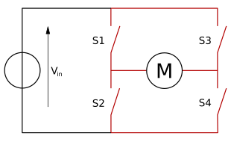

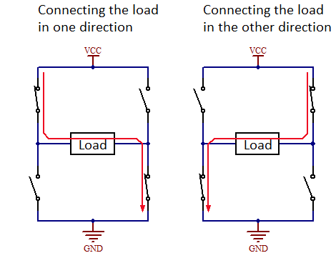

**OBSERVATION:**

|  |  |  |  |  |  |
| --- | --- | --- | --- | --- | --- |
| S1 | S2 | S3 | S4 | VOLTAGE  ACROSS MOTOR | MOTOR (ROTATION DIRECTION) |
| ON | OFF | OFF | ON | +Vcc | Clockwise |
| OFF | ON | ON | OFF | -Vcc | Anti-Clockwise |
| OFF | OFF | OFF | OFF | 0 | No Motion |
| ON | ON | OFF | OFF | 0 | Shoot-Through |
| OFF | OFF | ON | ON | 0 | Shoot-Through |
| ON | OFF | ON | OFF | 0 | Open-Circuit |
| OFF | ON | OFF | ON | 0 | Open-Circuit |
| ON | ON | ON | ON | 0 | Short-Circuit |

When the switches S1 and S4 are closed (and S2 and S3 are open) a positive voltage will be applied across the motor.

By opening S1 and S4 switches and closing S2 and S3 switches, this voltage is reversed, allowing reverse operation of the motor.

Using the nomenclature above, the switches S1 and S2 should never be closed at the same time, as this would cause a short circuit on the input voltage source. The same applies to the switches S3 and S4. This condition is known as **shoot-through**.

When the switches S1 and S3 are closed the motor is in open-circuit condition while when S2 and S4 are closed the motor is again in open-circuit condition.

When all the switches are closed short-circuit occurs.